Project : Phishing Website Detection

BUSINESS PROBLEM UNDERSTANDING DOCUMENT

Date: 05/02/2026
Intern: Ankit Bhumeshwar Katre

Summary
Phishing attacks remain one of the most prevalent cyber threats, accounting for approximately 15% to 30% of all security breaches. This project aims to develop a machine learning model capable of accurately distinguishing phishing websites from legitimate ones, thereby enhancing organizational cybersecurity defenses and protecting end-users from financial and data loss.
Phishing websites impersonate legitimate entities to deceive users into divulging sensitive information such as login credentials, credit card details, and personal identification. The consequences include:
- Financial losses for individuals and organizations
- Data breaches and privacy violations
- Reputational damage to legitimate businesses
- Erosion of user trust in online platforms

Scope:
The scope of this problem spans multiple industries, including banking, e-commerce, education, and government services, where users frequently interact with web-based systems. Traditional blacklist-based security approaches are often ineffective due to the rapid creation and short lifespan of phishing websites.Detecting phishing websites accurately and in real time is therefore critical to:
- Protect users from financial and identity loss
B) Maintain trust in digital platforms
C) Reduce organizational security risks and compliance issues
D) Machine Learning–based phishing detection systems offer scalable,adaptive, and automated solutions capable of identifying previously unseen phishing websites.
The project focuses on static analysis of website features (URL characteristics, HTML/JavaScript content, network information) rather than dynamic behavioral analysis or email-based phishing detection.

Project Objectives
- To analyze and understand key features that distinguish phishing websites from legitimate ones
- To develop a predictive model with high accuracy and low false-positive rates
- To provide actionable insights for cybersecurity teams
- To create a foundation for real-time phishing detection implementation
For us Success Metrics
- Model accuracy: >95%
- False positive rate: <5%

Key Insights and Takeaways from the Literature

Common Characteristics of Phishing Websites
Studies indicate that phishing websites exhibit distinguishable characteristics compared to legitimate ones. Common indicators include suspicious URL structures such as excessive length, use of IP addresses instead of domain names, multiple subdomains, and misleading special characters [1], [2].
Furthermore, phishing domains are often newly registered and have a very short lifespan, making domain age a strong indicator of malicious intent [3]. Phishing websites frequently imitate trusted brands by copying page layouts, logos, and titles, while also demonstrating abnormal behaviors such as hidden forms, abnormal redirects, and unauthorized form submissions [4], [5].

Detection Challenges
Despite advancements in detection techniques, phishing detection remains challenging. One major issue is the emergence of zero-day phishing attacks, which appear before blacklists can be updated [1].
High visual similarity between phishing and legitimate websites makes content-based detection difficult, especially for rule-based systems [6]. Additionally, attackers continuously evolve their techniques to bypass detection mechanisms, while real-world datasets often suffer from class imbalance, reducing the effectiveness of traditional classifiers [7].

Potential Solutions
The literature strongly supports machine learning–based detection approaches as effective solutions to phishing challenges. By learning patterns from URL, domain, and webpage features, ML models can identify previously unseen phishing websites more effectively than blacklist-based systems [2], [8].
Ensemble learning techniques further enhance detection accuracy and robustness by combining multiple classifiers [3]. Recent research also demonstrates that deep learning and hybrid models can automatically learn feature representations and adapt to evolving phishing strategies [9], [10].

Overall Takeaway
The literature concludes that phishing detection systems are most effective when multiple feature types are combined with intelligent learning models. Machine learning and deep learning–based approaches provide scalable, adaptive, and accurate solutions for real-world phishing detection [5], [7].

References
[1] J. Ma, L. K. Saul, S. Savage, and G. M. Voelker, “Beyond blacklists: Learning to detect malicious web sites from suspicious URLs,” Proc. 15th ACM SIGKDD Int. Conf. Knowledge Discovery and Data Mining, pp. 1245–1254, 2009.
[2] O. K. Sahingoz, E. Buber, O. Demir, and B. Diri, “Machine learning based phishing detection from URLs,” Expert Systems with Applications, vol. 117, pp. 345–357, 2019.
[3] M. Aburrous, M. A. Hossain, K. Dahal, and F. Thabtah, “Intelligent phishing detection system for e-commerce using classification mining techniques,” Expert Systems with Applications, vol. 37, no. 12, pp. 7913–7921, 2010.
[4] N. Chou, R. Ledesma, Y. Teraguchi, D. Boneh, and J. C. Mitchell, “Client-side defense against web-based identity theft,” Proc. NDSS, 2004.
[5] M. Khonji, Y. Iraqi, and A. Jones, “Phishing detection: A literature survey,” IEEE Communications Surveys & Tutorials, vol. 15, no. 4, pp. 2091–2121, 2013.
[6] A. Bergholz et al., “Improved phishing detection using model-based features,” Proc. CEAS, 2010.
[7] R. Al-Zaidy, B. C. M. Fung, A. Youssef, and M. Debbabi, “A comprehensive survey of phishing detection research,” IEEE Access, vol. 6, pp. 44350–44374, 2018.
[8] S. H. Basavaraj and R. C. Biradar, “Detecting phishing websites using classification ensemble techniques,” Proc. 3PGCIC, pp. 61–68, 2014.
[9] A. Y. Javaid et al., “A deep learning approach for phishing detection using hybrid feature embeddings,” Neural Computing and Applications, vol. 32, pp. 1277–1293, 2020.
[10] Y. Yang et al., “URL-BERT: Learning a URL representation using bidirectional transformers,” IEEE Transactions on Knowledge and Data Engineering, 2021.

Data Exploration report

- Dataset Overview

- Total Records (Rows): 11,430

- Total Features (Columns): 89

- Dataset Type: Structured, Tabular

- Target Variable: status

- Problem Type: Binary Classification (Phishing vs Legitimate)

- Objective of Dataset

The dataset is designed to identify phishing websites based on URL structure, domain information, web traffic, and security-related indicators using Machine Learning techniques.

- Feature Categories

URL-Based Features

- length_url

- length_hostname

- nb_dots

- nb_hyphens

- nb_at

- nb_percent

These features analyze URL complexity and suspicious patterns.

Domain & Host-Based Features
- Ip

- dns_record

- domain_age

- domain_registration_length

Used to check legitimacy of domain information.

Security & Web Indicators

- https_token

- google_index

- page_rank

- web_traffic
These features indicate trustworthiness and visibility of the website.

Target Variable

- status

- phishing

- legitimate

4. Data Types Summary
- int64 74
- float64 13
- object 2
- Name: count, dtype: int64

- Missing Values Analysis

No missing values found
All 89 columns contain complete data.

6.Duplicate Rows (Entire Dataset)

Total duplicate rows: 0

No completely identical rows found across all 89 columns.

This means your dataset does not contain repeated records with the same feature values.

7.Duplicate URLs

Duplicate URLs found: 1

The same website URL appears more than once

But other feature values may differ (e.g., traffic, ranking, status)

Why URL Duplicates Matter

In phishing detection: The URL is a unique identity
Duplicate URLs can: Bias the ML model Cause data leakage
Inflate performance metrics

8.Outlier Detection

What is an Outlier?
An outlier is a data point that significantly differs from other observations.
In phishing datasets, outliers often occur due to:
- Extremely long URLs
- Abnormally high number of special characters
- Very high web traffic or page rank
Outliers may represent real phishing behavior, so we must analyze before removing.

9.Method Used for Outlier Detection

Interquartile Range (IQR) Method
Best for:
Skewed data
Non-normal distributions
Cybersecurity datasets
Formula:

IQR = Q3 − Q1
Lower Bound = Q1 − 1.5 × IQR
Upper Bound = Q3 + 1.5 × IQR

Methodology

This project follows a structured machine learning methodology to develop an effective phishing website detection system. The overall approach ensures reliability, reproducibility, and scalability of the solution.

1. Problem Definition

The objective of this project is to classify websites as phishing or legitimate based on extracted features from URLs, domain information, and security-related indicators. The problem is formulated as a binary classification task, where the target variable status represents phishing or legitimate websites.

2. Data Collection

A structured phishing website dataset was used, containing 11,430 records and 89 features. The dataset includes:

- URL-based features

- Domain and host-based features

- Security and web traffic indicators

The dataset is labeled, making it suitable for supervised machine learning techniques.

3. Data Preprocessing

To ensure data quality and consistency, the following preprocessing steps were applied:

- Verification of missing values (none found)

- Identification and analysis of duplicate URLs to prevent data leakage

- Data type validation for numerical and categorical features

- Feature scaling applied where required for distance-based models

Outliers were identified using the Interquartile Range (IQR) method and analyzed carefully, as extreme values may represent genuine phishing behavior.

4. Exploratory Data Analysis (EDA)

EDA was conducted to understand data distribution, relationships, and anomalies:

- Analysis of feature distributions using histograms

- Detection of outliers using box plots

- Correlation analysis to identify influential features

- Examination of class distribution to assess imbalance

These insights guided feature selection and model choice.

5. Feature Engineering and Selection

Relevant features were selected based on:

- Domain knowledge from phishing literature

- Correlation analysis

- Feature importance scores from tree-based models

- Redundant and less informative features were minimized to improve model performance and reduce overfitting.

6. Model Development

Multiple supervised machine learning models were implemented and evaluated, including:

- Logistic Regression

- Decision Tree

- Random Forest

- Support Vector Machine (SVM)

- Ensemble-based classifiers

Models were trained using a train–test split, and hyperparameter tuning was applied where necessary.

7. Model Evaluation

Model performance was evaluated using standard classification metrics:
- Accuracy
- Precision
- Recall
- F1-score
- False Positive Rate

Special emphasis was placed on minimizing false positives to avoid misclassifying legitimate websites.

8. Model Interpretation

Feature importance analysis was performed to identify key indicators contributing to phishing detection. This improves transparency and provides actionable insights for cybersecurity teams.

9. Practical Implementation

The complete analysis, model development, and visualization were implemented in Python using libraries such as:

- Pandas, NumPy (data handling)

- Matplotlib, Seaborn (visualization)

- Scikit-learn (machine learning)

All code and results are documented in a Jupyter Notebook and made available via GitHub for reproducibility.

10. Future Scope

The methodology provides a foundation for:

- Real-time phishing detection systems

- Integration with web browsers or security tools

- Deployment using Flask or FastAPI

- Extension using deep learning models

Methodology Summary

This structured methodology ensures a systematic approach to phishing website detection, combining data-driven analysis with machine learning techniques to address real-world cybersecurity challenges.

Practical Work for EDA
For code and outputs follow the link given below
For visit click: hold ctrl + link
https://github.com/ankitkatre690-cmyk/phishing_website_detection/blob/cf4c30f7d69190e67b1d0aa4d166d88a448a69ce/Assignment1.ipynb
Or here some screenshots are given:-
Overview of dataset
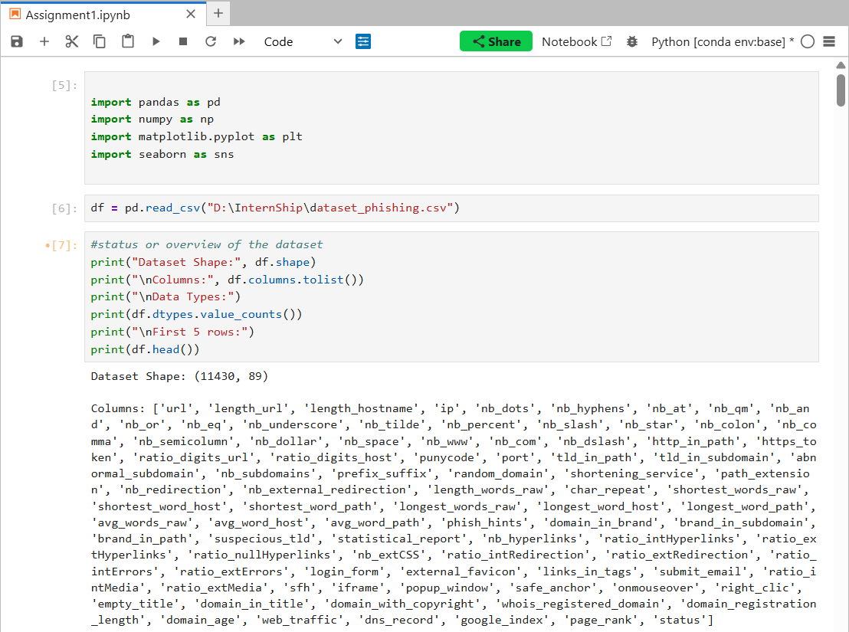

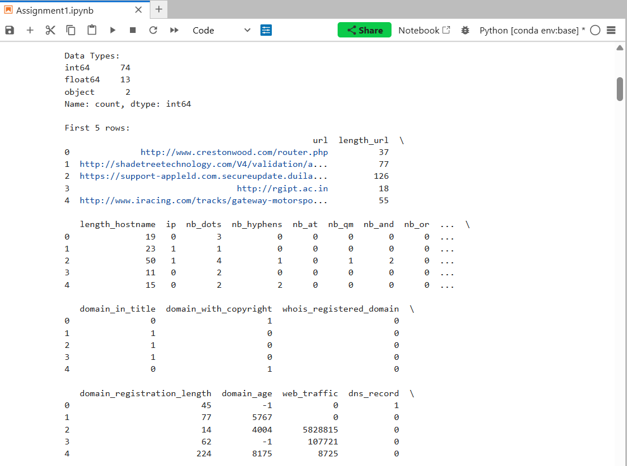

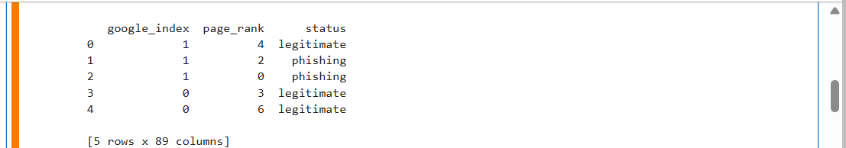

General info and missing values
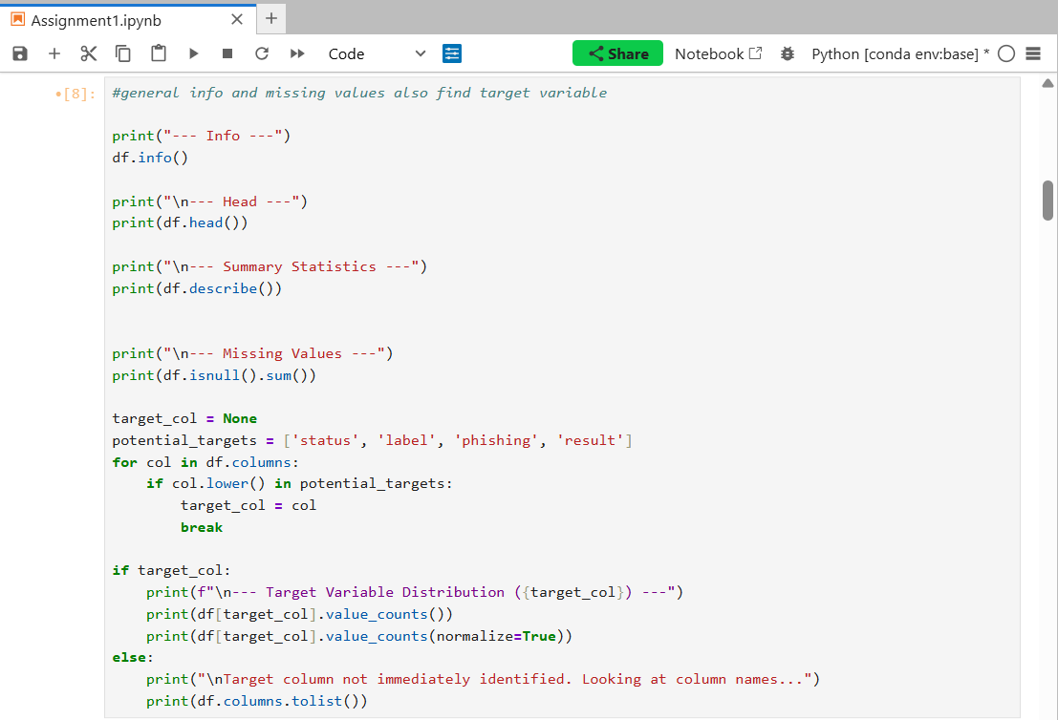
O/p:-

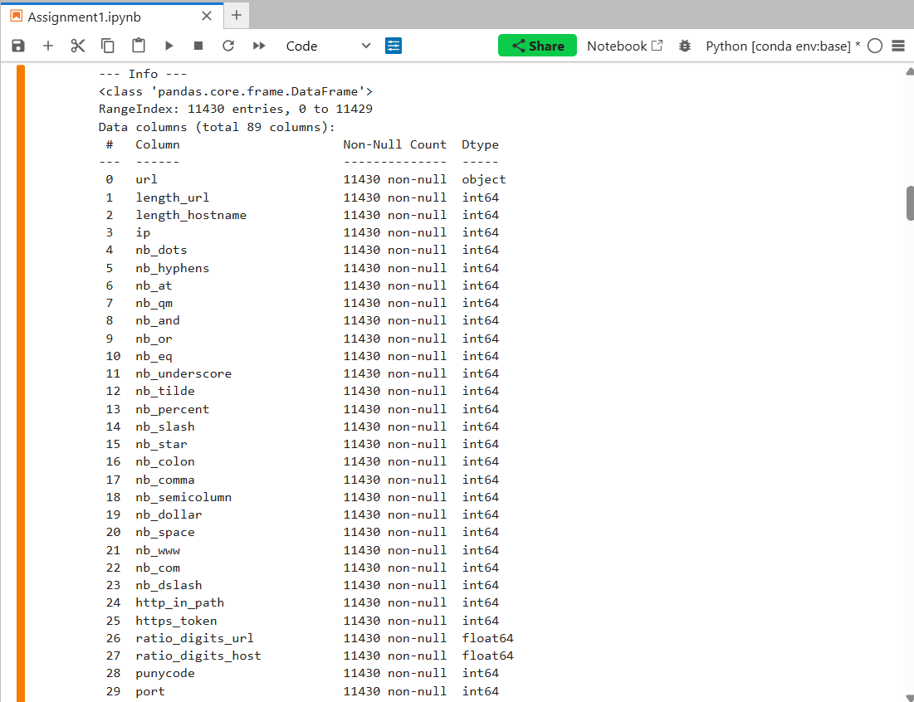

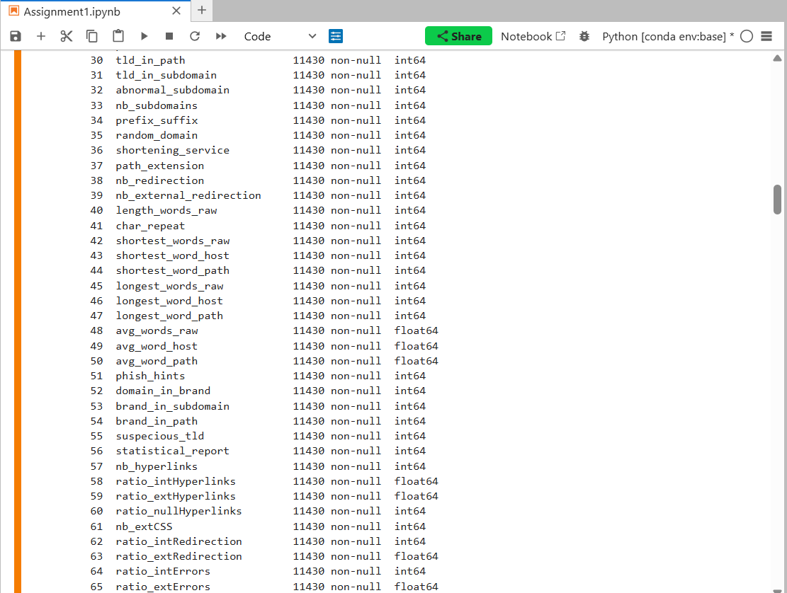

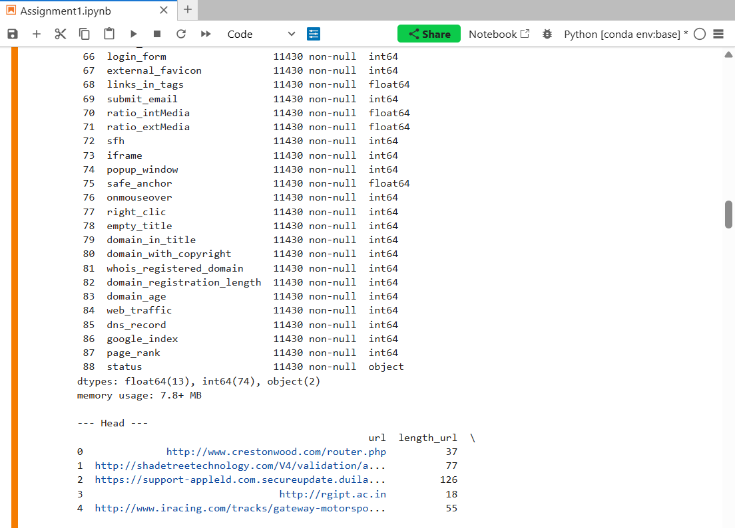

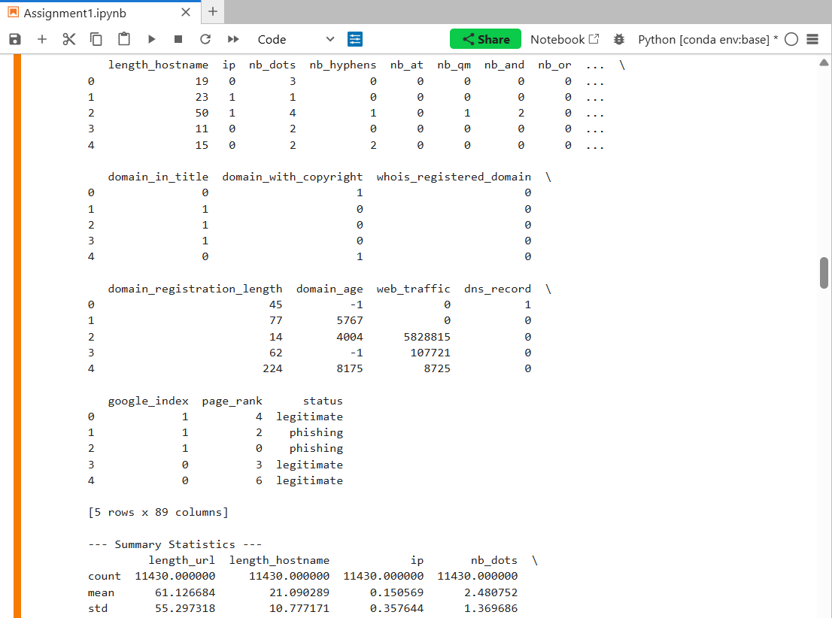
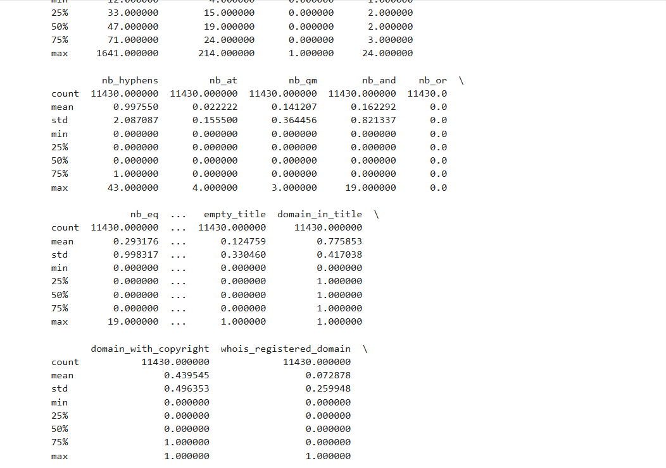
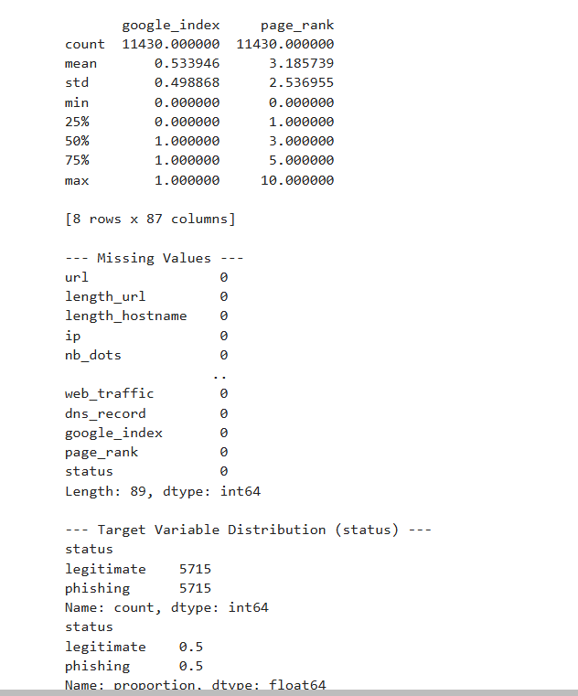

Visualization
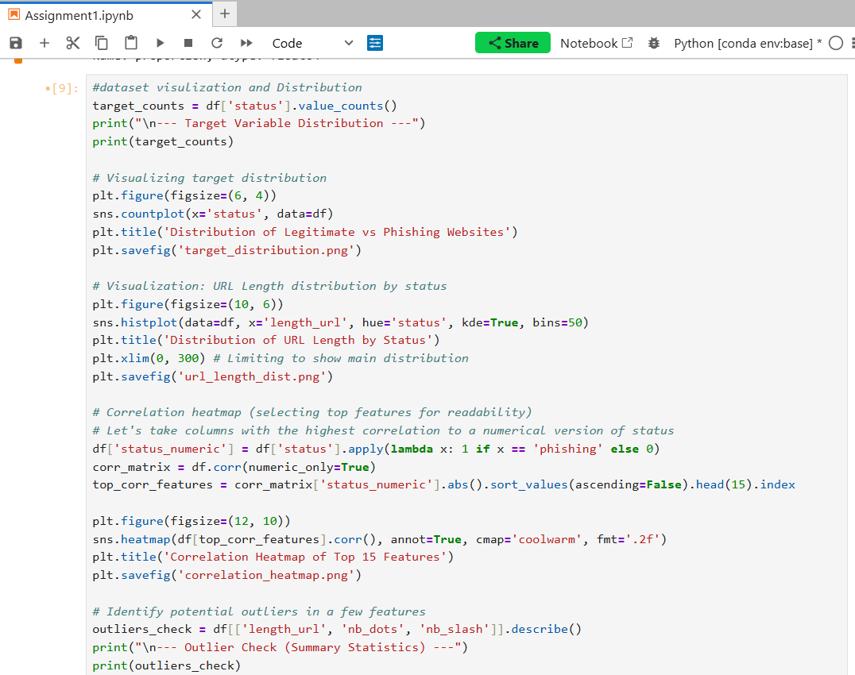
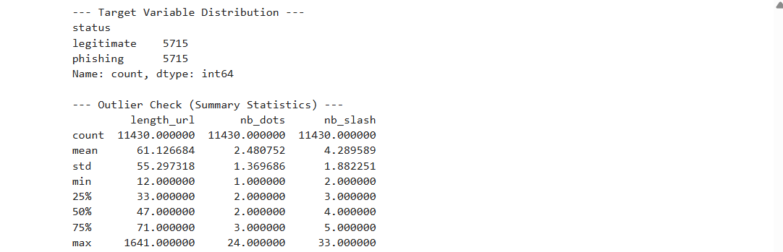
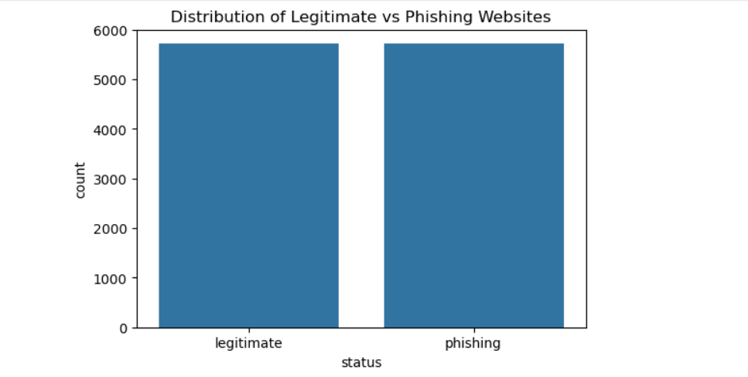
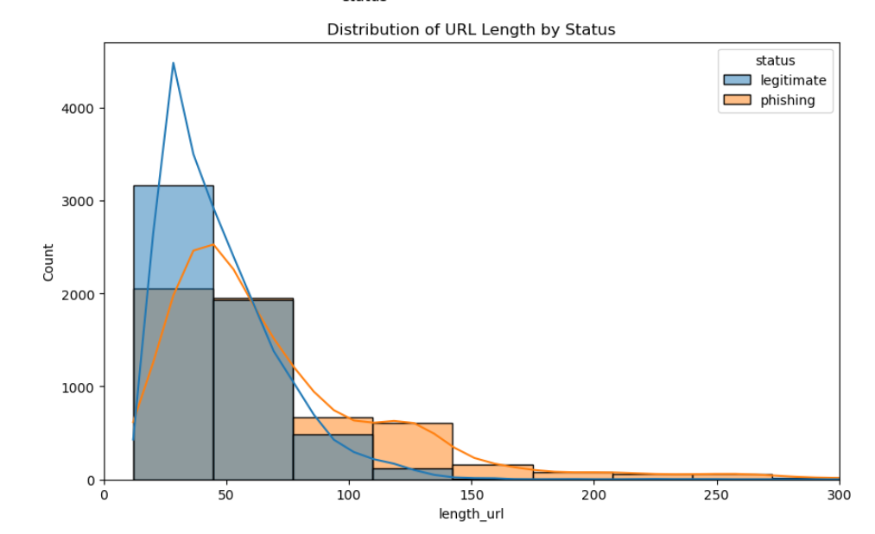
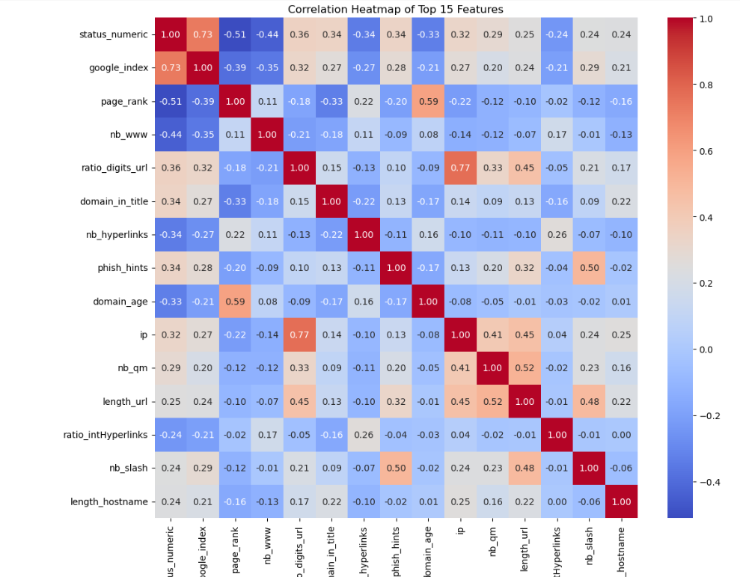
outliers
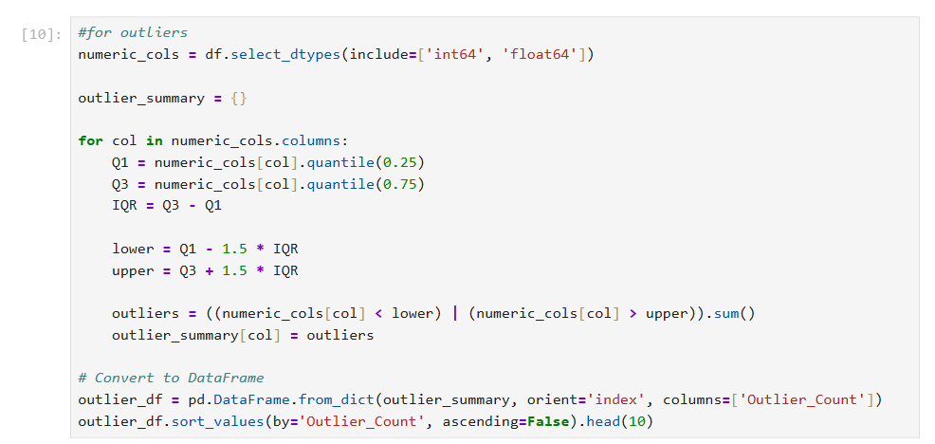
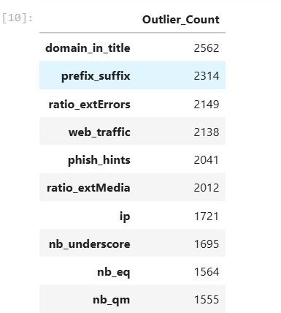
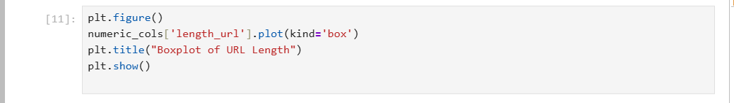
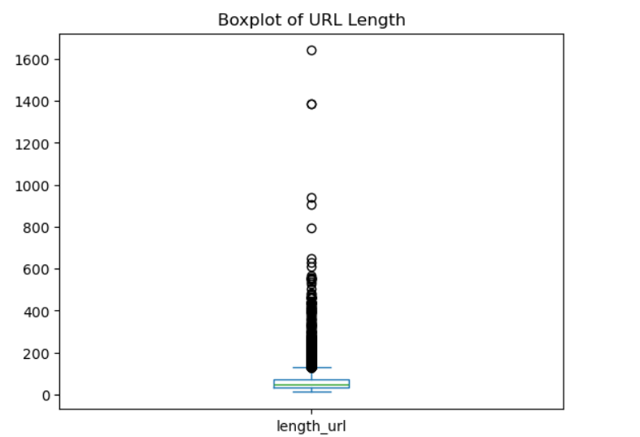
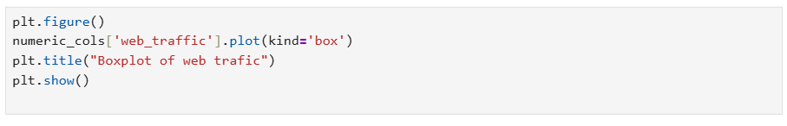
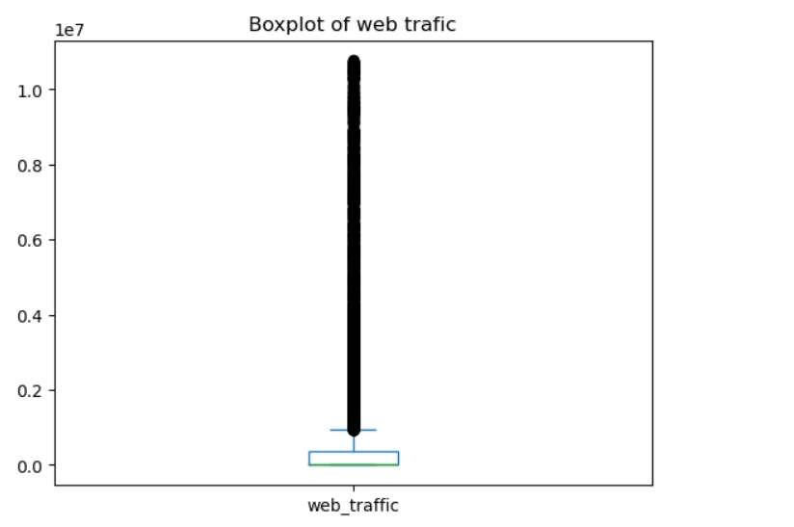
Duplicates
